LEAD MANAGEMENT SYSTEM
Organization: Gateway Group of Companies
A PROJECT REPORT
Submitted by
Mihir Joshi

In fulfillment for the award of the degree
of
BACHELOR OF ENGINEERING
in
COMPUTER ENGINEERING

VVP Engineering College, Rajkot
Gujarat Technological University, Ahmedabad
October, 2020
TABLE OF CONTENTS

Table of Contents i
Acknowledgement xiii
Abstract xiv
1. INTRODUCTION 1
2. SYSTEM ANALYSIS & DESIGN 5
3. IMPLEMENTATION 24
4. CONCLUSION & DISCUSSION 29
5. REFERENCES 30

ACKNOWLEDGEMENT
Whether it is brainstorming a project-idea, implementing the actual project, or finding solutions to the problems that we face, without the consistent support of the people I am surrounded by, this project would not be performing to its potential. That being said, it is my duty to thank all the ones who helped me in this project directly or indirectly.
My sincere thanks to our guide Dr. Maulik Dhamecha for guiding us throughout the journey and solving our queries whenever we faced any.
I would also like to thank my friends who have been there every single time I needed them.

ABSTRACT
Lead Management System for car dealers, wherein the end-user will be sending inquiries for new car or service for an old car to car dealers.

- INTRODUCTION
1.1 PROJECT SUMMARY
Lead Management System for car dealers, wherein the end-user will be sending inquiries for new car/service for an old car to car dealers.
Domain: Automotive
Audience: Car Dealers
Car Dealers will use this solution to manage leads. Leads can be of two types, depending upon their request for new car or old car service.
1.2 PURPOSE: GOALS & OBJECTIVES
Goals:
- To provide a solution to the end-users of this website – Car Dealers, which helps them manage Leads effectively.
- The solution can be used by Car Dealers as well as their employees in the expected manner.
- Dealer Managers should be able to easily manage their Leads using this solution.
- Dealer Managers should be able to gain necessary insights on the Lead Management for their particular organization.
Objectives:
- To provide a robust solution for Car Dealers to manage leads.
1.3 PROBLEM SPECIFICATIONS
The Lead Management System solution is intended to be provided to the Car Dealers, so that their Lead entries from a specified source is inserted into the system. Leads can be posted/added to the system by providing an API Endpoint.
Users of this system will be able to see the newly added Leads as well as already present Leads from the database. Users should be able to effectively manage this system with minimum effort.

  - LITERATURE REVIEW & PRIOR ART SEARCH
In the initial phase of this project, the team was scheduled to work on analysis, planning, design thinking, and documentation. In this phase, we researched about Leads, Leads Management, and various similar search terms which are related to this project.
We came to many solutions which were providing a similar functionality for a different domain. We read blogs, and tried various articles to clear the flow of this project.
After researching and understanding the problem statement for enough time, we worked on documenting the initial features of this project and brainstormed it.

  - Plan
November 24th – December 7th: Analysis, Research, Design Thinking, Documentation
December 7th – January 19th: Review of Analysis, Documentation
January 19th: Implementation begins
January 19th – January 31st: Define Data Dictionary, Project Architecture and Project Setup
February 1st – March 7th: Coding Phase
  - Materials/Tools
- Visual Studio 2019
- SQL Server
- ASP.NET MVC
- ASP.NET Web API
- Git
2. SYSTEM ANALYSIS & DESIGN
2.1 ANALYSIS
To gain more clarity about the project, we researched and analyzed the current solutions which provide a similar functionality.
We defined the problem statement, and also defined the roles that we will be providing in the solution.
As the first step of beginning the project, we started with Data Dictionary.

Brands
Column name | Column datatype | Constraint
Id | INT | IDENTITY, PRIMARY KEY
Name | NVARCHAR(50)
BrandCode | NVARCHAR(20) | UNIQUE
CreatedDate | DATETIME
UpdatedDate | DATETIME (ALLOW NULL)
CreatedBy | INT
UpdatedBy | INT (ALLOW NULL)
IsActive | BIT
Dealers
Column name | Column datatype | Constraint
Id | INT | IDENTITY, PRIMARY KEY
Name | NVARCHAR(50)
State | NVARCHAR(50)
City | NVARCHAR(50)
Pincode | VARCHAR(10)
SalesEmail | VARCHAR(50) (ALLOW NULL)
AfterSalesEmail | VARCHAR(50) (ALLOW NULL)
DealerCode | NVARCHAR(20) | UNIQUE
CreatedDate | DATETIME
UpdatedDate | DATETIME (ALLOW NULL)
CreatedBy | INT
UpdatedBy | INT (ALLOW NULL)
IsActive | BIT
2.2 DATA DICTIONARY
Users
Column name | Column datatype | Constraint
Id | INT | IDENTITY, PRIMARY KEY
Name | NVARCHAR(50)
DealerId | INT | FOREIGN KEY, REFERENCES Dealers.Id
Email | VARCHAR(50) | UNIQUE
Password | VARCHAR(128)
MobileNumber | VARCHAR(15) (ALLOW NULL)
RoleId | INT | FOREIGN KEY, REFERENCED Roles.Id
CreatedDate | DATETIME
UpdatedDate | DATETIME (ALLOW NULL)
CreatedBy | INT
UpdatedBy | INT (ALLOW NULL)
IsActive | BOOL

DealerBrandMappings
Column name | Column datatype | Constraint
Id | INT | IDENTITY, PRIMARY KEY
DealerId | INT | FOREIGN KEY, REFERENCES Dealers.Id
BrandId | INT | FOREIGN KEY, REFERENCES Brands.Id
CreatedDate | DATETIME
UpdatedDate | DATETIME (ALLOW NULL)
CreatedBy | INT
UpdatedBy | INT (ALLOW NULL)
IsActive | BIT

Models
Column name | Column datatype | Constraint
Id | INT | IDENTITY, PRIMARY KEY
Name | NVARCHAR(50)
BrandId | INT | FOREIGN KEY, REFERENCES Brands.Id
FuelType | VARCHAR(10) / TINYINT (ALLOW NULL)
TransmissionType | VARCHAR(10) (ALLOW NULL)
ExteriorColor | NVARCHAR(20) (ALLOW NULL)
InteriorColor | NVARCHAR(20) (ALLOW NULL)
ModelCode | NVARCHAR(20) | UNIQUE
CreatedDate | DATETIME
UpdatedDate | DATETIME (ALLOW NULL)
CreatedBy | INT
UpdatedBy | INT (ALLOW NULL)
IsActive | BOOL
IsDeleted | BOOL
DeletedDate | DATETIME (ALLOW NULL)

Leads
Column name | Column datatype | Constraint
Id | INT | IDENTITY, PRIMARY KEY
CustomerName | NVARCHAR(50)
DealerId | INT | FOREIGN KEY, REFERENCES Dealers.Id
ModelId | INT | FOREIGN KEY, REFERENCES Model.Id
AssignedUserId | INT (ALLOW NULL) | FOREIGN KEY, REFERENCES Users.Id
CustomerEmail | VARCHAR(50) (ALLOW NULL)
CustomerContactNumber | VARCHAR(15) (ALLOW NULL)
LeadStatusId | INT | FOREIGN KEY, REFERENCES LeadStatus.Id
LeadTypeId | INT | FOREIGN KEY, REFERENCES LeadType.Id
ServiceId | INT (ALLOW NULL) | FOREIGN KEY, REFERENCES Services.Id
Comments | NVARCHAR(MAX) (ALLOW NULL)
CreatedDate | DATETIME
UpdatedDate | DATETIME (ALLOW NULL)
UpdatedBy | INT (ALLOW NULL)
UserComments | NVARCHAR(MAX) (ALLOW NULL)

Lead Type
Column name | Column datatype | Constraint
Id | INT | IDENTITY, PRIMARY KEY
DisplayName | VARCHAR(20)
LeadTypeCode | VARCHAR(20) | UNIQUE

Lead Status
Column name | Column datatype | Constraint
Id | INT | IDENTITY, PRIMARY KEY
DisplayName | NVARCHAR(50)
LeadStatusCode | VARCHAR(20) | UNIQUE
LeadTypeId | INT | FOREIGN KEY, REFERENCES LeadType.Id
Roles
Column name | Column datatype | Constraint
Id | INT | IDENTITY, PRIMARY KEY
Name | NVARCHAR(50)
RoleCode | NVARCHAR(20) | UNIQUE

Services
Column name | Column datatype | Constraint
Id | INT | IDENTITY, PRIMARY KEY
Type | VARCHAR(20)
Date | DATETIME
VIN / RegistrationNumber | VARCHAR(20) (ALLOW NULL)

2.3 ROLES
Admin
- Admin is the developer of the system
DealerManager
- Dealer Manager is a person in the Car Dealer’s Organization who has the rights to manage the Users in the organization and the Leads
User: Sales/AfterSales
- Users are the employees of the Car Dealer’s Organization
- There are two types of Users:
  - Sales: Deals with the Leads who want to buy a new Car
  - After-Sales: Deals with the Leads who request for service of an existing Car

2.4 SCREENS
Login
- Username (Email)
- Password
Forgot Password
- Enter email
- An OTP will be sent to the specified Email
- After verifying OTP, User is redirected to Set Password Screen
Change Password (after login)
- If User wants to change intentionally → Old Password
- New Password
- Confirm Password

Dashboard
Dashboard is displayed differently based on the logged-in user/role. Here is the dashboard specifications based on roles:
Admin
Will have links to:
- Dealer List Page
- Models List Page
- Brands List Page
- Users List Page
DealerManager
- Statistics: We can provide useful insights for the Dealer
- Link to Lead Details/Lead List Page
- Link to Users (Employees) Page - Users List

User
- Lead List based on their role
  - E.g.: Only Sales Lead are shown if the logged-in user is a Sales Representative.
  - Clicking on a particular Lead will redirect to Lead Details Page
  - Assign/De-assign Leads Option (Row)

Create
- Will contain Partial View for each of the Create Pages (e.g.: Create Dealer)
Admin
Super-Admin can create new information with specified fields,
- Dealer
- Model
- Brand
- User
DealerManager
DealerManager can create,
- Users

Edit
- Will contain Partial View for each of the Edit Pages (e.g.: Edit Dealer)
Admin
Admin can Edit,
- Dealer
- Model
- Brand
- User

DealerManager
DealerManager can Edit,
- Users
Details
- Will contain Partial View for each of the Detail Pages (e.g.: Details of a Dealer)
Admin
has access to
- Dealer Details
- Model Details
- Brand Details
- User Details
DealerManager
has access to
- User Details
Dealer List Page
Has access to only Admin
- Have details of particular Dealer with functionality like edit, delete(Soft delete) from that particular record.
- Clicking on a particular dealer would display Dealer Details
Model List Page
Admin
- Have details of particular Model with functionality like Edit, Delete(Soft delete) from that particular record.
- Clicking on a particular Model would display Model Details
DealerManager
- Have details of particular Model
- Clicking on a particular Model would display Model Details
- Link to Add Models (to current Dealer) Page
Brands List Page
Admin
- Have details of particular Brand with functionality like Edit, Delete(Soft delete) from that particular record.
- Clicking on a particular Brand would display Brand Details
- Link to Create Brands Page
Users List Page
Admin, DealerManager
- Have details of particular User with functionality like Edit, Delete(Soft delete) from that particular record.
- Clicking on a particular User would display User Details
- Link to Create Users Page
Leads List Page
DealerManager
- Will have a list of all types of Leads (Sales + AfterSales)
- Clicking on a particular Lead would display Lead Details Page
- DealerManager can Assign leads to a User
- Will have Sorting and Searching based on various parameters
User
- Will have a list of only the types of Leads the User has access to
- Clicking on a particular Lead would display Lead Details Page
- User can Assign Leads to himself
- Will have Sorting and Searching based on various parameters

Lead Details Page
DealerManager, User
- Will have all the details for a particular Lead

2.5 USE-CASE DIAGRAM
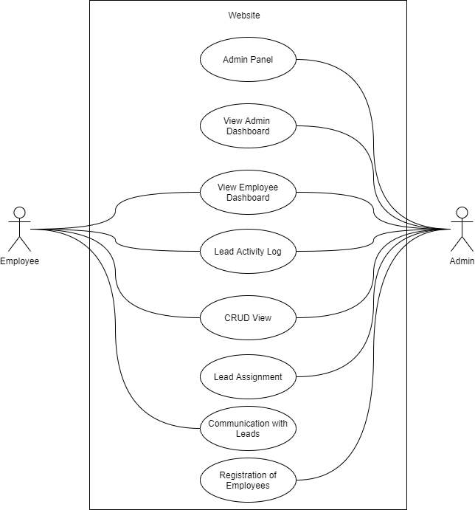

2.6 CONTROL FLOW DIAGRAM
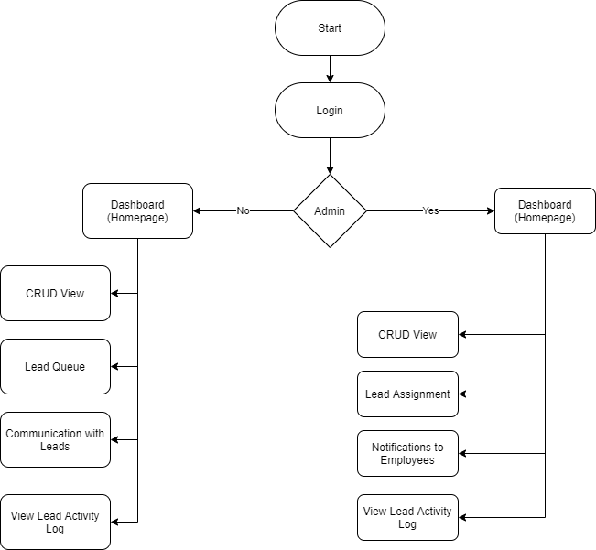

2.7 DATABASE DESIGN
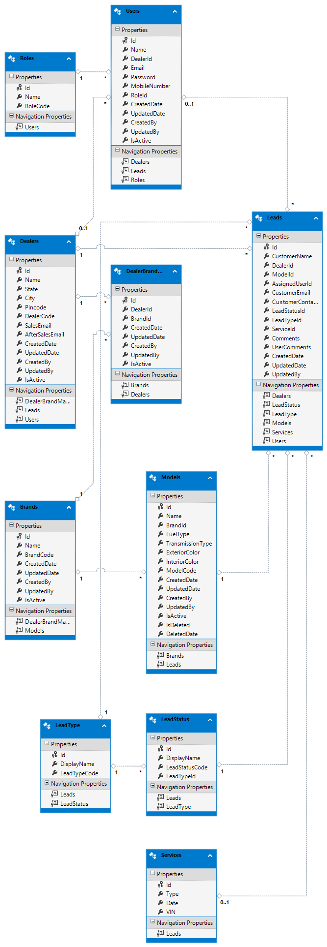
2.9 CANVAS
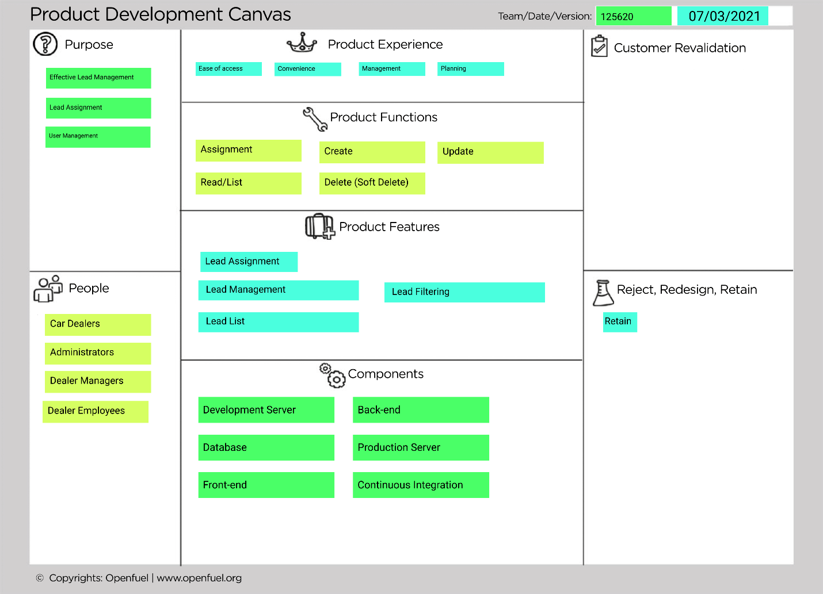
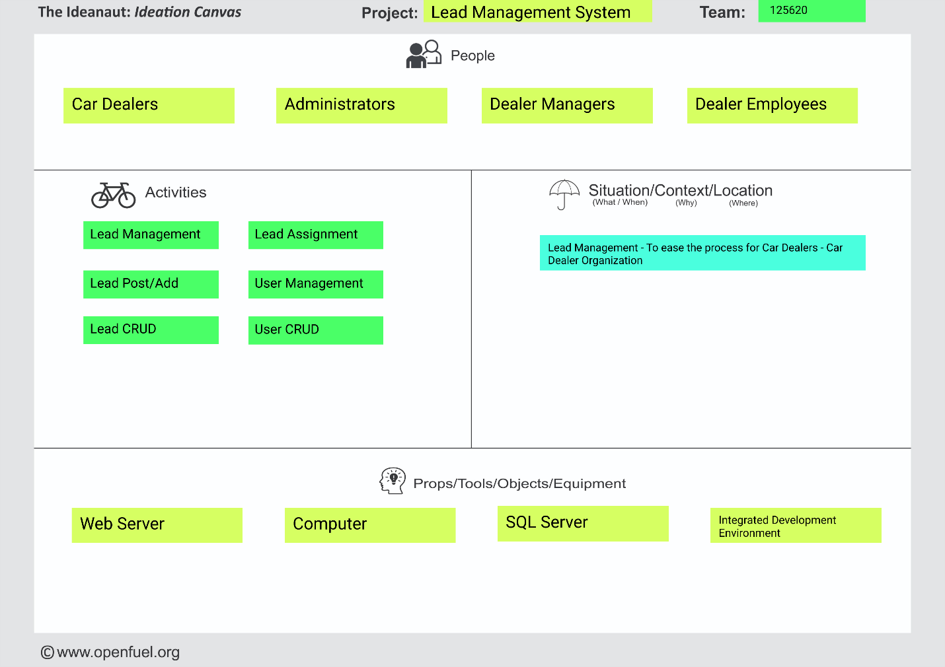

3. IMPLEMENTATION
3.1 Solution Architecture

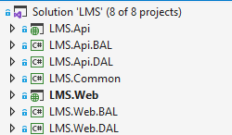
3.2 Snapshots
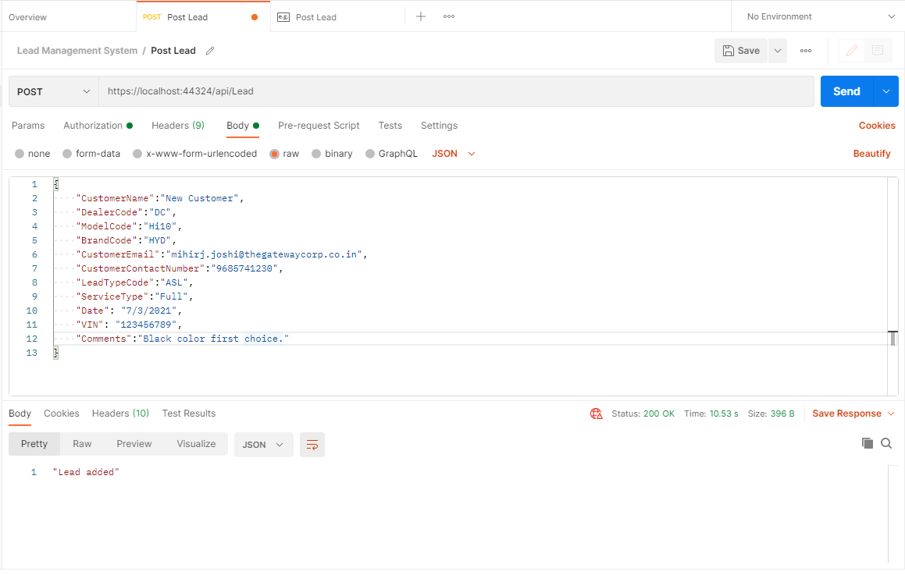
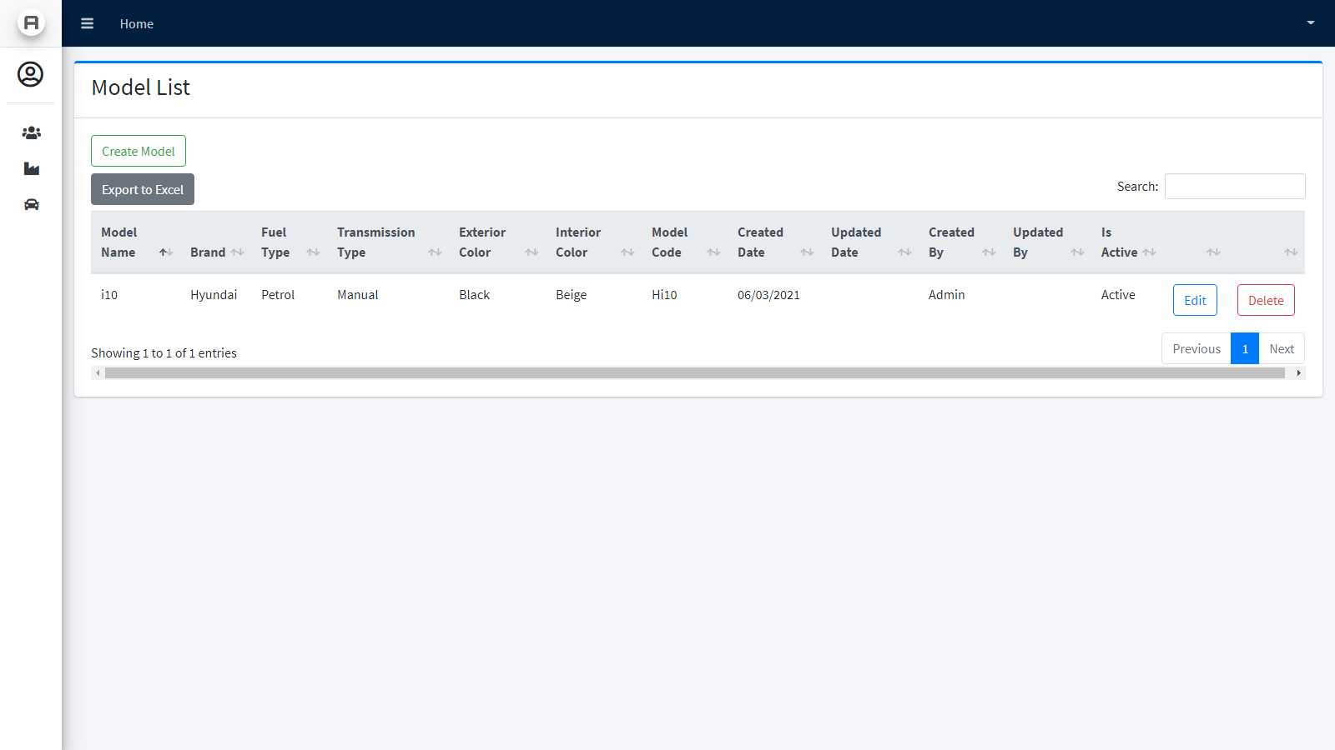
List of Models 1
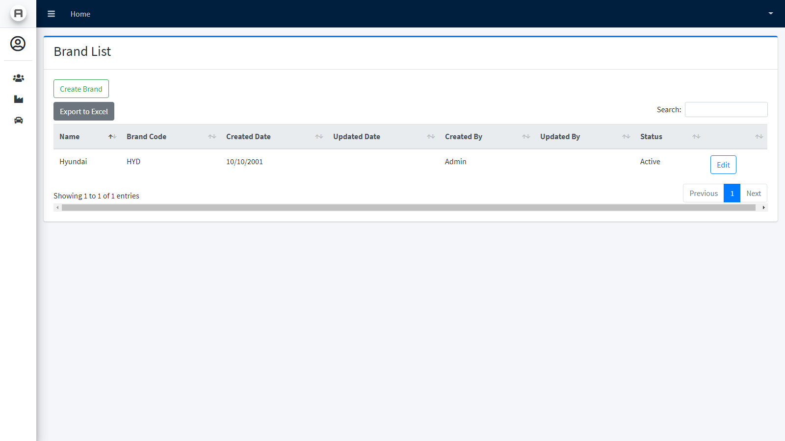
List of Brands 1
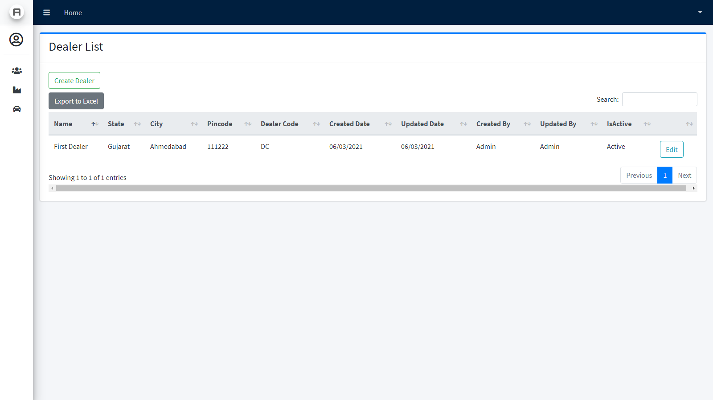
List of Dealers 1
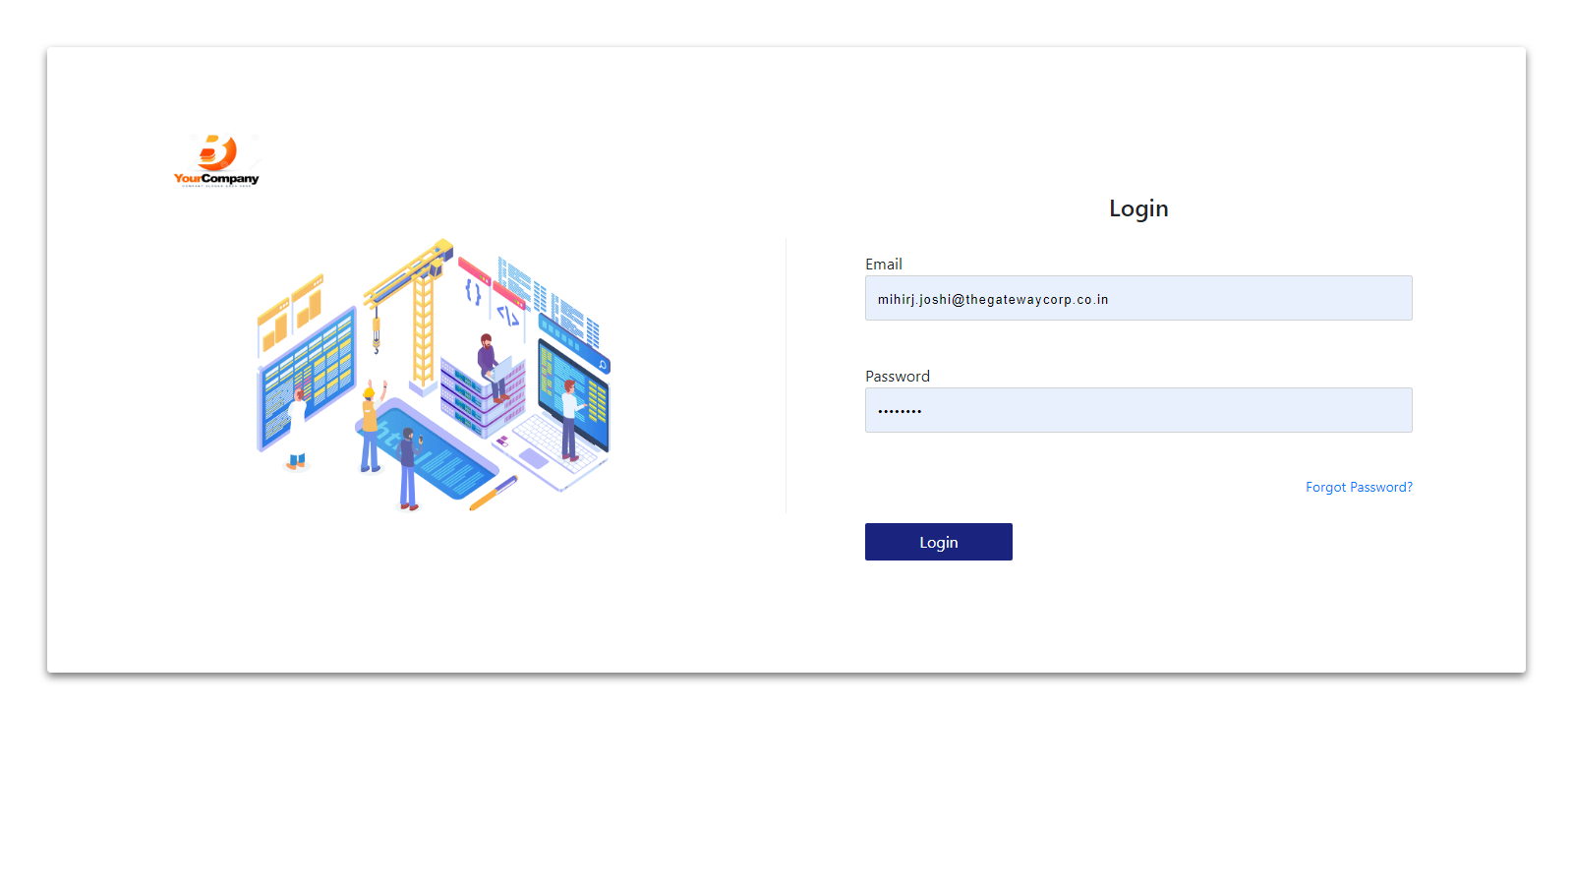
Login 1
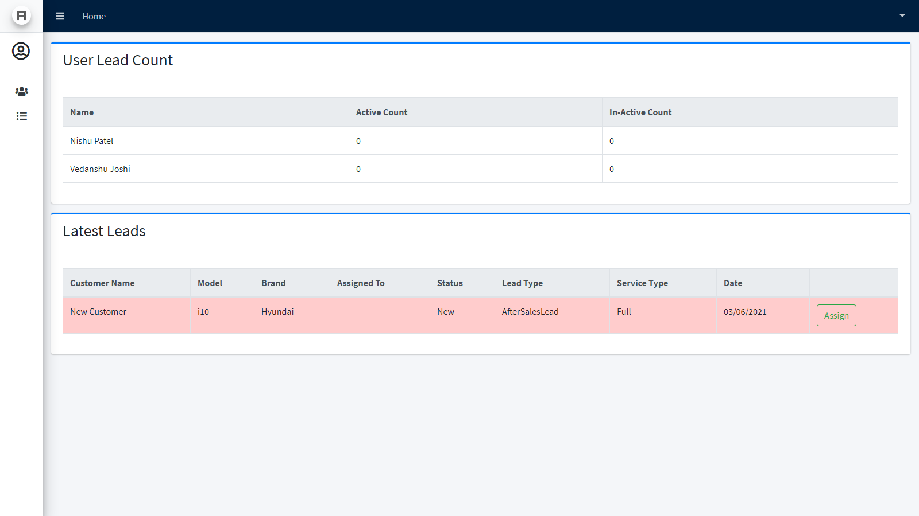
Dealer Dashboard 1
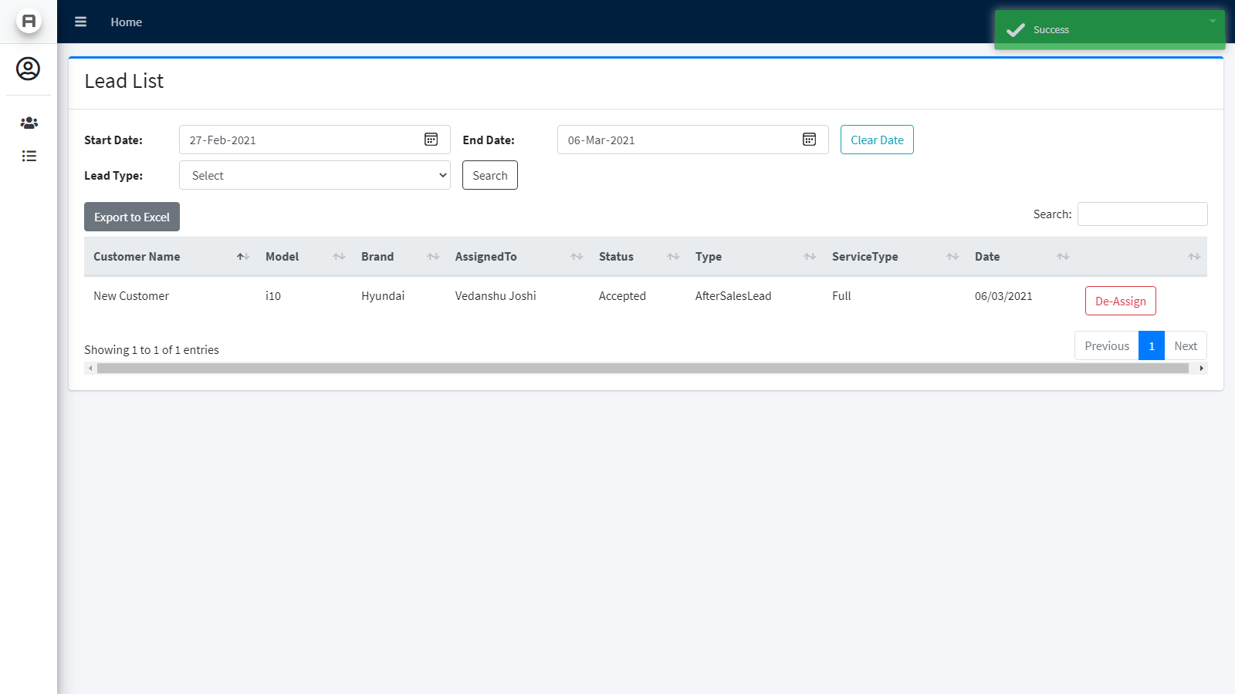
Lead List (Dealer) 1
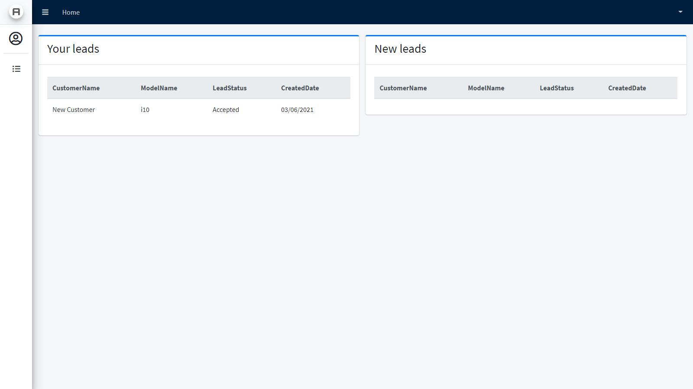
User Dashboard 1
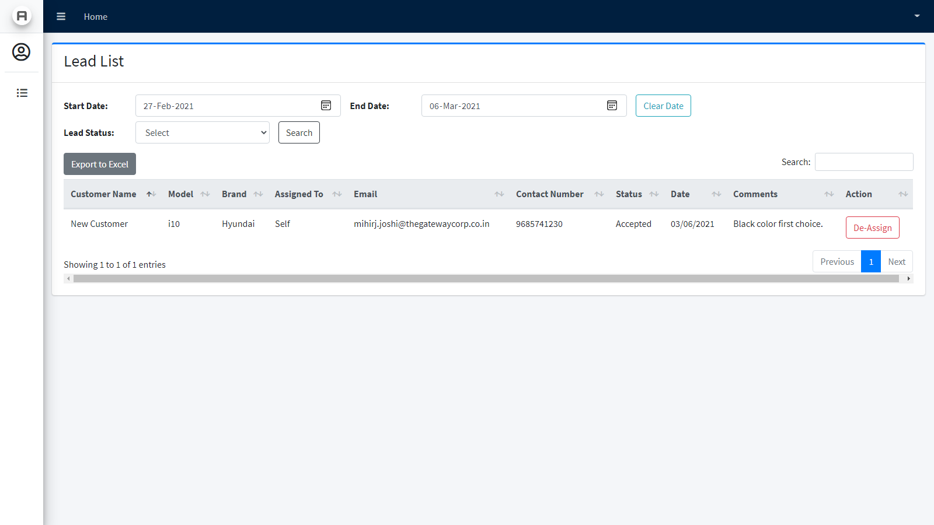
User Lead List 1

4. CONCLUSION & DISCUSSION
Since the beginning of this project, me and my teammates have been very enthusiastic about the project. Even in the documentation phase, we enjoyed the process of analyzing and researching about the project.
Now that the project is in its final stages, we feel grateful for this opportunity to create this project.
If time permits, we will be working on the next set of features that we have planned.

5. REFERENCES

[1] Entity Framework. Retrieved from https://docs.microsoft.com/en-us/aspnet/mvc/overview/getting-started/getting-started-with-ef-using-mvc/creating-an-entity-framework-data-model-for-an-asp-net-mvc-application
[2] ASP.NET MVC. Retrieved from https://dotnet.microsoft.com/apps/aspnet/mvc
[3] ASP.NET Web API. Retrieved from https://docs.microsoft.com/en-us/aspnet/web-api/
[4] Lead Management System. Retrieved from https://www.leadsquared.com/lead-management-system/?utm_source=Pay%20per%20Click%20Ads&utm_medium=adwords&utm_campaign=Lead%20Management%20Software&utm_term=lead%20management%20software&gclid=Cj0KCQiA7YyCBhD_ARIsALkj54qsytc8KMhvpjNrmCMyoApuPPrVyqcQdwoLdJhsAgg5j25i2MR9ZVAaAnuuEALw_wcB
[5] What is Lead Management. Retrieved from https://www.zoho.com/crm/lead-management.html#:~:text=Drive%20more%20sales%20with%20our,leads%20through%20the%20sales%20pipeline.
[6] Lead Management & Tracking. Retrieved from https://www.hubspot.com/products/crm/lead-management

